ODA Extensions and BIRT Part 3
Welcome to Part Three
In the first two articles in this series we focused on the design time and runtime extensions of an Open Data Access (ODA) driver for use within the BIRT environment. As stated in the previous articles, ODA is the framework that BIRT uses to access data for report consumption. In this the third and final article on the BIRT ODA we cover the following topics:

- Logging - Implement appropriate logging strategy
- Optimization – Design time and runtime performance.
- DataTypes – Add support for column data types
- Parameters – Add support for Data Set Parameters

As with the previous articles we will continue building on the Google Spread-Sheet ODA. This ODA has been designed to retrieve data stored in Google Spread-Sheets by a given user.

Since the start of this series, Google has released new java client libraries and the BIRT project has released a new milestone build on the Europa release train. In an effort to keep current, we have moved all of the code to the latest versions of both, so the requirements have changed.
Requirements to Deploy and Run Examples

- Eclipse BIRT 2.2 Milestone 6 or higher.
- GData java client libraries gdata.java-1.0.9.zip
- Sun's JavaMail API (version 1.4 or greater)
- Sun's JavaBeans Activation Framework 1.1

Logging
There are a plethora of techniques that can be used for logging in any application. The ODA framework provides extensive logging on each of the methods called within the ODA framework. To enable the base ODA logging, you need to modify the trace logging settings. The output from the trace logging will be placed under the runtime workspace metadata folder. For the google_runtime component the logs will appear at: ../.metadata/.plugins/org.eclipse.datatools.connectivity.oda.consumer/logs/google_runtime
Figure 1 illustrates setting the trace logging settings.

Figure1.PNG
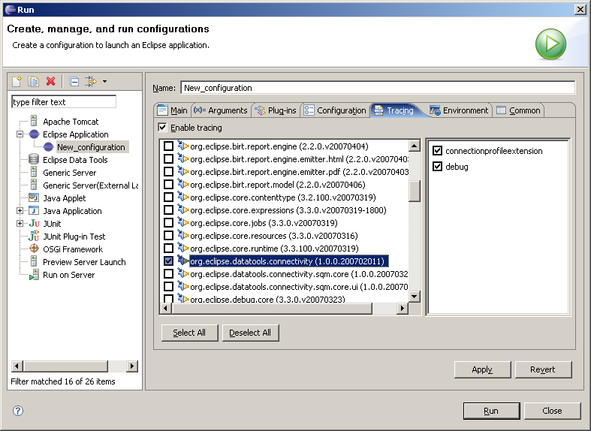
Figure 1: Trace Logging Configuration
The DTP team does not recommend adding you’re logging methods to the framework logging, but does provide an element within the DataSource extension point that allows you to configure log settings for your data source. This DataSource element supports defining the logging level, file location and formatter. The extension is configured through the manifest editor as shown below:

Figure2.png
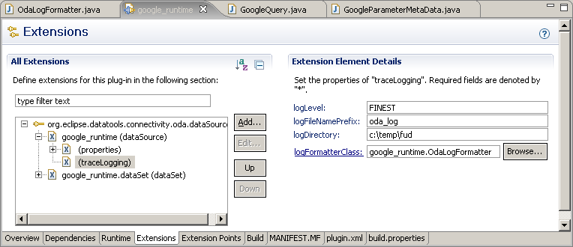
Fig. 2: Add Trace Logging Element

Once the trace logging element has been added, the IDriver.setLogConfiguration method needs to be modified to use the new logging configuration. This means that you need to decide on a log strategy (log4j, commons.logging, java.util.logging…) and then configure your log strategy with the information passed in through the plugin framework.
For this article the java.util.logging package is used, which is configured through a static logging utility class. This class is appropriately named LogConfig and is placed in the source for the plugin. In the LogConfig class the ODA log levels are translated to java.util.logging levels and the logger is assigned the appropriate log handlers. Since the GoogleDriver class implements the ODA IDriver interface, we can modify the setLogConfiguration method to call the LogConfig utility class as follows:

public void setLogConfiguration(LogConfiguration logConfig) throws OdaException
{
LogConfig.setLogConfiguration(logConfig);
logger.fine("logging started");
}

The LogConfig class will then interact with the java.util.logging packages to setup logging. The key points in the LogConfig implementation are to:
- Translate the Oda LogLevel to your frameworks log levels.
- Create a package logger for your ODA’s logging
- Attach your logger to the appropriate handlers (console, file, db…)

See the example source for more detail.

Design Time and Run Time operation
When you look at ODA optimization, there is a big difference between Design time and Run time behavior. Design time operation includes methods within your ODA that are invoked when you are using either the DataSource or DataSet editors. Run time operation covers the calls that are executed when you actually run your report through the preview tab, the WebViewer, or an instance of the ReportEngine.
The DTP and BIRT developers had a trade off to make in the UI design, should they cache a significant amount of information about the ODA, or should they query the ODA for the information as needed. For various reasons, the developers tend to prefer re-query of the data at Design Time. This is good for the developer, since you are not required to manually refresh the data as you work in the DataSet editor. The performance implications of this choice make the DataSet editor slower, meaning the framework calls to your ODA will occur many times, but typically this is not a significant burden. In addition, the DataSet editor can cache data if you choose to use this feature which is located under settings within the DataSet editor.
The Run time portion of the ODA code is a different story. For the most part the code is optimized to minimize the round trips between the DataSource and the report.
If you feel that you need to optimize your ODA code, you will typically want to focus on the run time behavior. It is probably not worthwhile to invest a significant amount of time into the optimization of your ODA code to improve the DesignTime performance.
DataTypes
In the examples from the previous articles, all of the data contained in the SpreadSheets was represented by Strings. This made the ODA relatively easy, but placed a burden on the report developer to handle proper data interpretation when formatting in a report. A better approach is to evaluate the data in the SpreadSheet to determine the data type of the columns.
To implement data typing the first thing to do is modify the GoogleResultSetMetaData class to evaluate the first and second rows of data. The first row is used to determine the column headers and the names of the fields. The second row is used as a sample to determine the data value. The new ResultSetMetaData constructor is presented below:

private List<String> colHeaders = new ArrayList<String>();
private List<Integer> colDataType = new ArrayList<Integer>();
protected static Logger logger = Logger.getLogger(GoogleResultSetMetaData.class.getName());

public GoogleResultSetMetaData(List<ListEntry> entries) {
logger.info("RESULT SET META DATA");
int rowNum = 0;
for (ListEntry listEntry : entries)
{
if (rowNum == 0)
{
for (String tag : listEntry.getCustomElements().getTags())
{
colHeaders.add(tag);
}
} else
{
for (String tag : listEntry.getCustomElements().getTags())
{
Integer dataType = geDataType(listEntry.getCustomElements().getValue(tag));
colDataType.add(dataType);
}
break;
}
rowNum ++;
}

The getDataType method determines the data type from the value of the data and returns the proper ODA data type. The code for this method is relatively straight-forward.

private Integer getDataType(String sampleValue) {
Date td = DateParser.parse(sampleValue);
if (td != null)
return Types.DATE;

// Not a date, check if it is a number
if (sampleValue.indexOf('.') > 0) {
try {
Double tDbl = new Double(sampleValue);
} catch (NumberFormatException e) { // do nothing it is not a number
}
return Types.DOUBLE;
}

try {
Integer tDbl = new Integer(sampleValue);
} catch (NumberFormatException e) {
// Wasn't an Integer must be a String
return Types.CHAR;
}

return Types.INTEGER;

}

After modifying the ResultSetMetaData, the ResultSet code can now be altered to handle the various data types as follows:

public int getInt(int index) throws OdaException
{
String colName = this.resultSetMetaData.getColumnName(index);
return getInt(colName);
}

public int getInt(String columnName) throws OdaException
{
return new Integer(curRow.getCustomElements().getValue(columnName));
}

public double getDouble(int index) throws OdaException
{
String colName = this.resultSetMetaData.getColumnName(index);
return getDouble(colName);
}

public double getDouble(String columnName) throws OdaException
{
return new Double(curRow.getCustomElements().getValue(columnName));
}

public Date getDate(int index) throws OdaException
{
String colName = this.resultSetMetaData.getColumnName(index);
return getDate(colName);
}

public Date getDate(String columnName) throws OdaException
{
return DateParser.parseToSql(curRow.getCustomElements().getValue(columnName));
}

Writing the code to implement DataTypes is a little tedious, but there are a number of benefits for the report developer when you do this. For instance, the developer can now create locale independent code and they can use appropriate format masks.
Parameters
BIRT supports Report Parameters and Data Set Parameters. The primary difference is that Report Parameters are global report objects and Data Set Parameters are used within the scope of a Data Set. The Data Set Wizard provides a convenient facility to link a Data Set Parameter to a Report Parameter as illustrated in figure 3.
Figure3.png
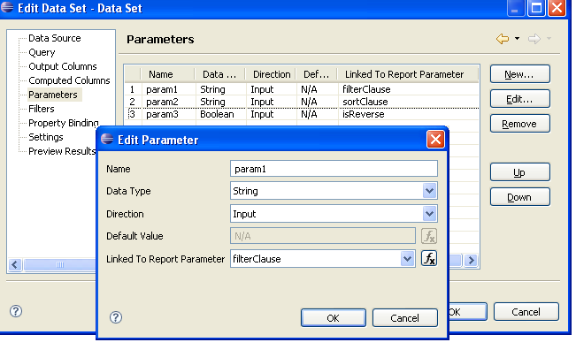
Fig. 3: Linking Report Parameters to Data Set Parameters

The ODA framework provides mechanisms that allow adding Data Set Parameters to your ODA. In the case of our ongoing Google ODA example, we can add a parameter to filter our results, change the order or returned results, and add a sort clause. These are three parameters that a Google ListQuery supports. This can be accomplished by first adding three variables to the GoogleQuery class, each representing the respective parameter.

private Boolean isReverse = null;
private String filterClause = null;
private String sortClause = null;

Next the createFeed method should be modified as follows.

private void createFeed() throws OdaException {
logger.info("=========================================");
try {
// feed URL
targetURL = new URL(queryText);
} catch (MalformedURLException e) {
logger.severe("Query: URL failure");
throw new OdaException(e);
}

// USE Parameters in the query
ListQuery query = new ListQuery(targetURL);
//query.setMaxResults(maxResults)
if (isReverse != null)
query.setReverse(isReverse);

if (filterClause != null && filterClause.trim().length() > 0) {
query.setSpreadsheetQuery(filterClause);
}

if (sortClause != null && sortClause.trim().length() > 0) {
query.setOrderBy("column:" + sortClause);
}

try {
feed = service.query(query, ListFeed.class);
} catch (IOException e) {
logger.severe("Query: IO Exception");
throw new OdaException(e);
} catch (ServiceException e) {
logger.severe("Query: ServiceException");
throw new OdaException(e);
}

}
This change passes the parameter values to the Google ListQuery. To have the parameters show up in the designer we will need to modify the auto-generated GoogleParameterMetaData class, which implements the IParameterMetaData interface. This class is called by the designer whenever the Data Set wizard is used to create or modify a query and describes parameter metadata to the ODA framework. Within this class the ODA framework first calls the getParameterCount method to determine how many parameters exist. So in our example if we desire three parameters we can just hard code the number as follows.

public int getParameterCount() throws OdaException
{
return 3;
}

Although we hardcode the number here it is important to realize that the ODA Framework will call the GoogleQuery prepare method before making this call. In the JDBC ODA delivered with BIRT the prepare method will create a java.sql.ParameterMetaData object which is read in the getParameterMetaData method and allows the number of parameters to be dynamic. For illustrative reasons we have decided to hard code the number of parameters to three. Once the ODA framework knows how many parameters exist it will then call the remaining methods in the GoogleParameterMetaData class for each parameter. Parameters are numbered starting with one. In our example the two most important methods are presented below.

public int getParameterMode(int param) throws OdaException
{
logger.info("" + param);
return IParameterMetaData.parameterModeIn;
}

public int getParameterType(int param) throws OdaException
{
switch (param)
{
case 1:
return Types.CHAR;
case 2:
return Types.CHAR;
case 3:
return Types.BOOLEAN;
default:
return Types.CHAR;
}
}
The getParameterMode call informs the framework on parameter directionality. The ODA framework currently supports input, output, and in-out parameters. Once again the parameter direction could be dynamic, but in our example we support only three input parameters. The getParameterType method returns the parameter data type. In our example the first two parameters are string types and the final parameter is a Boolean.
Finally the GoogleQuery setString and setBoolean methods will be called for the defined parameters before the executeQuery method is executed, which occurs anytime the result set is needed. These methods are passed the value of the parameters as stored in the report design. So when the Google ODA is deployed and executed the framework will first call the GoogleQuery.prepare method, then the GoogleQuery.setString/Boolean methods for each parameter and finally GoogleQuery.executeQuery. The set methods are shown below.

public void setString(int parameterId, String value) throws OdaException {
if (value == null)
return;

logger.info(parameterId + " " + value.toString());

if (1 == parameterId)
setFilterClause(value);

if (2 == parameterId)
setSortClause(value);
}

public void setBoolean(int parameterId, boolean value) throws OdaException {
logger.info(parameterId + " " + value);
setIsReverse(value);
}

These methods set the respective values defined in the class earlier for each parameter. In the executeQuery method the createFeed method will then be called using the new parameter values.

public IResultSet executeQuery() throws OdaException {
logger.info("");
if (isChangeParameter) {
createFeed();
isChangeParameter = false;
}

IResultSet resultSet = new GoogleResultSet(feed);
resultSet.setMaxRows(getMaxRows());
return resultSet;
}

Due to an existing bug in the 2.2 M6 build you will also need to add the Boolean data type mapping to the google runtime plugin.xml as shown below.

<dataTypeMapping
nativeDataType="Boolean"
nativeDataTypeCode="16"
odaScalarDataType="Boolean">
</dataTypeMapping>
</dataSet>

To illustrate the changes we can create a new report that uses the Google ODA and query the DataTypeExample Spreadsheet using sheet one. Once the query is entered select the parameters tab and link the new Data Set Parameters to three new Report Parameters as illustrated back in Figure 3. You will need to manually set the parameter type for parameter three to Boolean. This query will return four columns which can then be filtered, sorted and ordered. Presented below is an example of using the parameters and the expected output.

Figure4.png
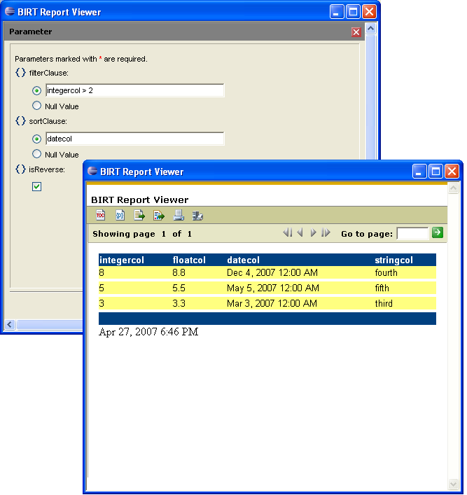
Fig. 4: Example Report using new Parameters

Summary
This wraps up our short series on creating custom ODA extensions. Some other interesting features of ODA to take a look at are output parameter support, multiple data set types and the use of the Application Context object which allows developers to integrate their BIRT reports with objects that have been exposed or shared through session, application or an EJB.
Please drop by our blog at http://birtworld.blogspot.com if you have questions, comments or to let us know what types of interesting things you are doing with BIRT.
References & Resources
- Eclipse BIRT Project Home Page: http://www.eclipse.org/birt
- Eclipse BIRT 2.1 Download: http://download.eclipse.org/birt/downloads

